Drury University Holiday Shootout
Lake of the Ozarks Osage Beach, MO
Takeoff/Weigh in out of Robins Resort
Sunday, November 28, 2021
Safe Light – 3 pm
Open to all collegiate fishing teams

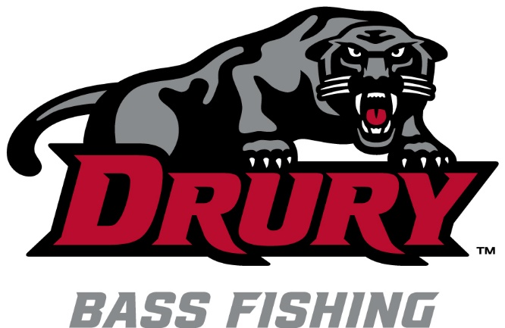

Tournament Director/Questions contact Coach Rick Emmitt at remmitt@drury.edu or call 417-860-2303

Entry Fee - $60 (Includes $10 Big Bass Pot)
80% payback, 20% goes to the Drury University Fishing Team

Additional draw prizes after weigh-in

Register Online at collegiatebasschampionship.com. Please complete registration form and bring with you to pre-tournament meeting. Cash or Venmo accepted at ramp the morning of the tournament.
Phone Registration - Anglers may enter by phone at least one week prior to the event by calling 417-860-2303.
Tournament Morning Registration - Anglers may enter the morning of the tournament from 6 am – 6:30 am. Cash or Venmo accepted.

This event qualifies for Bass Pro Shops ACA School of the Year Points
There is no limit to the number of schools each team may enter

