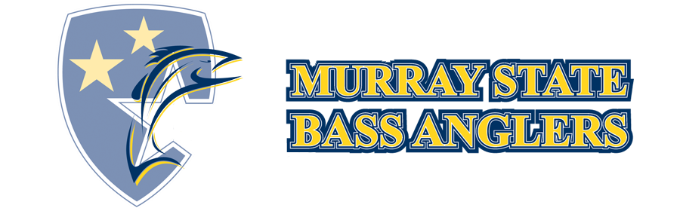
There is $1,000 Guaranteed Payout for First Place
Cadiz Kentucky,
Zip 42211
2021
Murray State
Spring Invitational
Contact Ryan Park (815-999-1898)
with any questions.

Registration:

Please pre-register on ACA website.

Final Registration 5:00-5:30 AM at the ramp tournament morning.

Rules Meeting: 5:30-5:45 AM

Entry Fee:

The entry fee for the 2021 Murray State Spring Invitational is $90.00 per team; a big bass option will be available
for $10.00 per boat ($100.00 total) PLEASE PAY IN CASH ONLY
There will be a 75% entry fee payback, with 25% going towards the Murray State Bass Anglers.

*Tournament winnings will be awarded immediately following the conclusion of the weigh-in.

Takeoff and Weigh-In Location:

Lake Barkley Marina

4200 State Park Rd.

Sunday April 25th

A.M Tournament Take-Off
6:00

2:00
P
.M
.
:

W
e
i
g
h
-
In

License Requirements:
A valid Kentucky fishing license is required for fishing in all Barkley/Kentucky Lake waters

Lake Barkley Marina
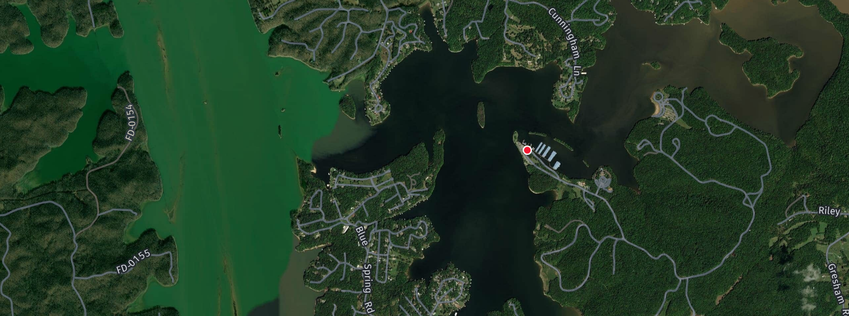

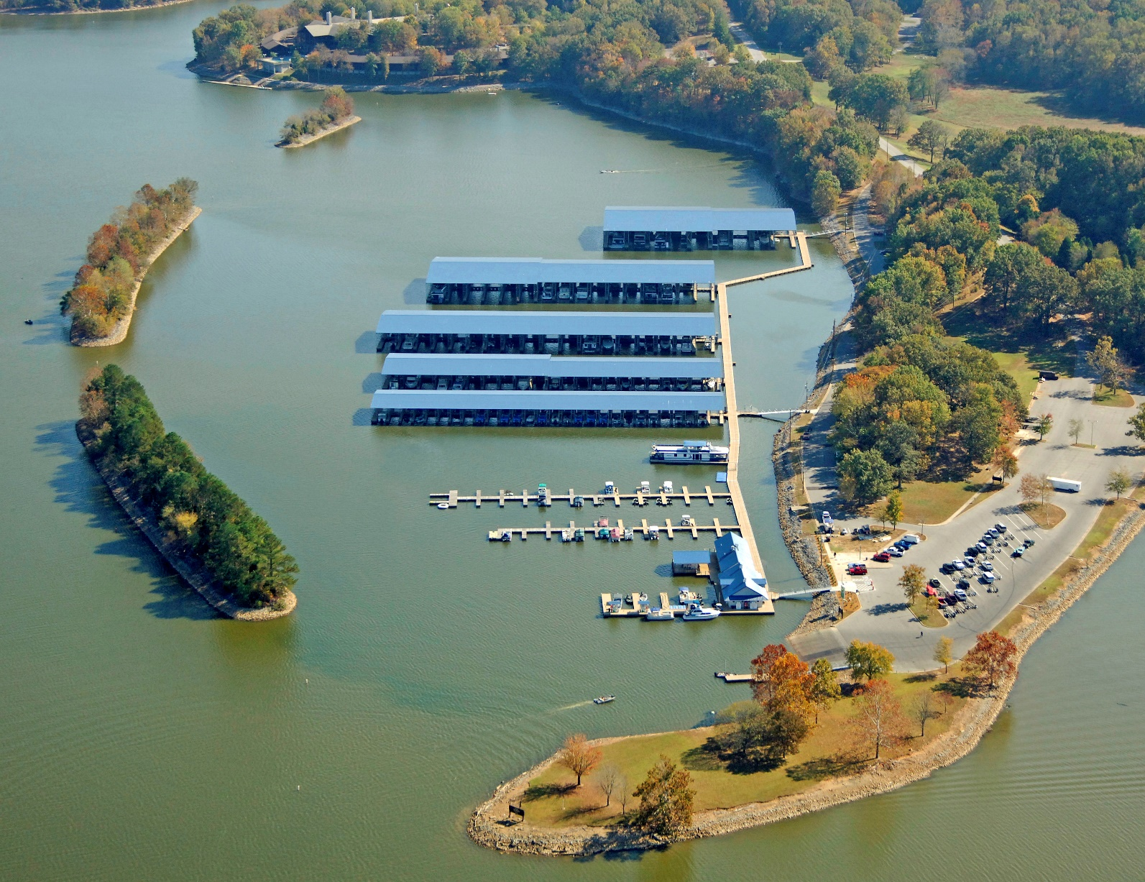

OFFICIAL TOURNAMENT RULES:

Participation in the 2021 Murray State University Lake Barkley Invitational constitutes each contestant’s
understanding of and full and unconditional agreement to and acceptance of these Official Rules. Contestants must obey all State, Federal and local fishing, and safety laws. The Tournament Director reserves the right to disqualify any contestant that is determined to be in violation of any term contained in these Official Rules. The Tournament Director’s decision not to enforce a specific provision of the Official Rules does not constitute a waiver of that provision or of the Official Rules generally. Interpretation of these rules will be left exclusively to the Tournament Director. Decisions of the Tournament Director are final in all matters and are not subject to appeal. At the sole discretion of the Tournament Director, entry may be refused to any individual or university fishing club/team. Protests must be made in writing within 15 minutes of the official check-in time.

- Teams are defined as two collegiate anglers per boat.
- 5 fish limit per day.
- Winners will be determined by tournament officials based on a 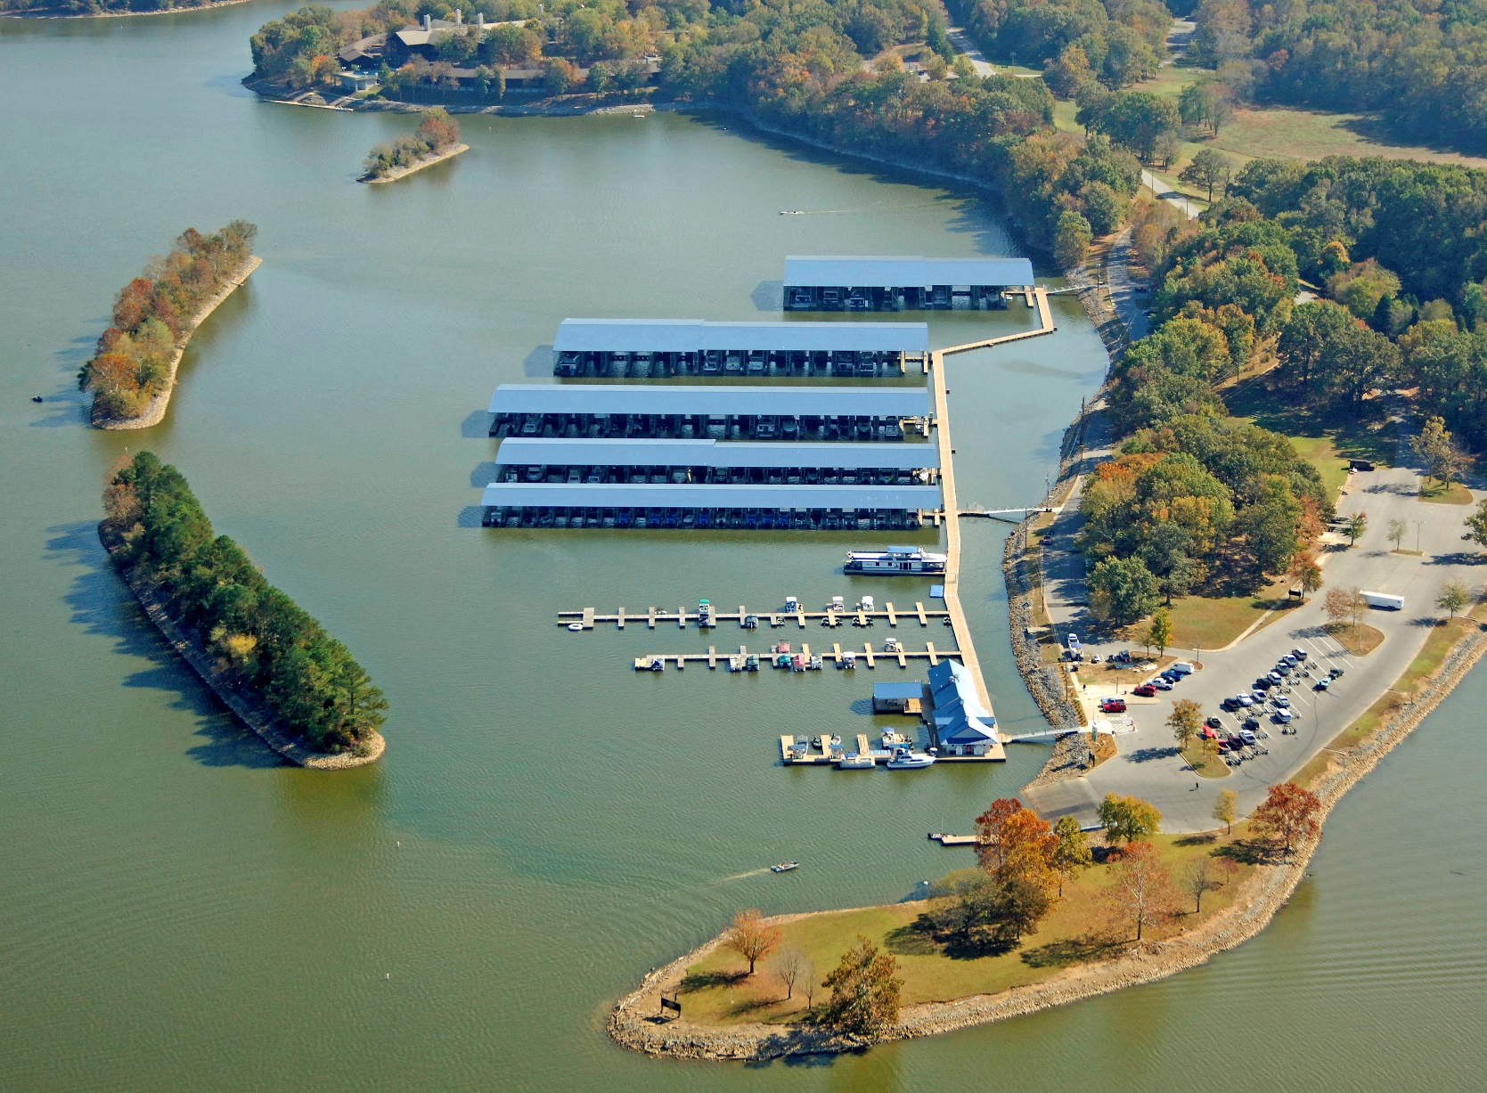one day weight total.
- Only largemouth, smallmouth, spotted bass, and mean-mouth (Smallmouth/Spotted Bass Hybrid) can be weighed.
- Size Limits: 15-inch minimum for all species.
- There will be a two pound penalty for each “short” fish brought to the scales. There will be an eight ounce penalty for each dead fish brought to the scales Late Penalty: one pound per each minute late.
- More than 15 minutes late your day’s weight will be forfeited.
- Only artificial lures may be used; trolling is not permitted.
- All boats must be equipped with a Coast Guard approved kill switch.
- The horsepower of the outboard must not exceed the max horsepower capacity for the boat. Boats must contain a properly aerated livewell space to maintain a live limit catch of bass.
- A livewell inspection must be completed each morning.
- All boats must pass boat inspection before taking off each day.
- Coast Guard approved PFD must be worn when combustion engine is running above idle speed. Locking is not permitted.
- The use of drugs/alcohol is prohibited.
- All decisions of tournament directors are final.

* Contact Ryan Park (815-999-1898) with any questions.

Participation / Eligibility:

Participation is open to college students who are enrolled full time in an accredited NCAA college or university and are members in good standing of that college or university’s institutionally recognized fishing club. All participants will be required to show a current student ID and a state issued photo ID upon request

Each team must provide its own equipment including, without limitation, fishing equipment, and a boat, all subject to the restrictions contained in these Official Rules.

All contestants must have in their possession a valid fishing license

Registration & Pre-Tournament Meeting:

Each contestant must check in or register in person at the designated site during the official registration hours. All contestants must be present during the pre-tournament meeting unless authorized by the Tournament Director.

Sportsmanship:

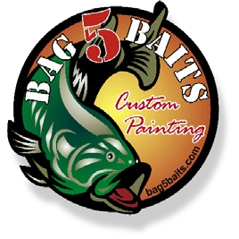
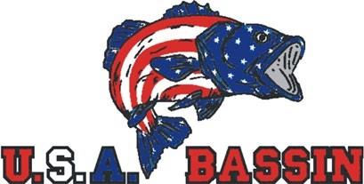
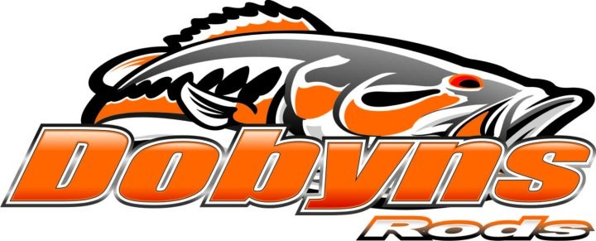
All contestants are required to follow high standards of sportsmanship, courtesy, and conservation and to conduct themselves in a manner that will be a credit to themselves, their school, event sponsors, the sport of fishing and the

Violation of or failure to comply with any of the official rules for the Tournament.
Consumption and/or possession of any alcoholic beverages or any kind of mind-altering substance during
registration, the pre-tournament meeting or during tournament hours extending through the weigh-in are
strictly prohibited.
Conviction of a felony within the past 36 months.
Suspension/disqualification from any fishing tournament or organization.

In other words, conduct or actions reflecting unfavorably upon efforts to promote safety, sportsmanship, fair
competition and compliance with tournament rules, or which fail to comply with the standards set forth in this
paragraph.

In case of any conduct not complying with the standards, the Tournament Director shall have the right to refuse any
application, or to deny a confirmed application, by returning the registration of a previously accepted application to
disqualify a contestant.

Permitted Fishing Methods:

-
All bass must be caught alive in a conventional sporting manner.
-
When sight fishing, all bass must be hooked inside the mouth.
-
Only artificial lures may be used with the exception of pork rinds.
-
Only one fishing rod per angler may be used at a time.
Trolling as a method of fishing is not allowed.
-

